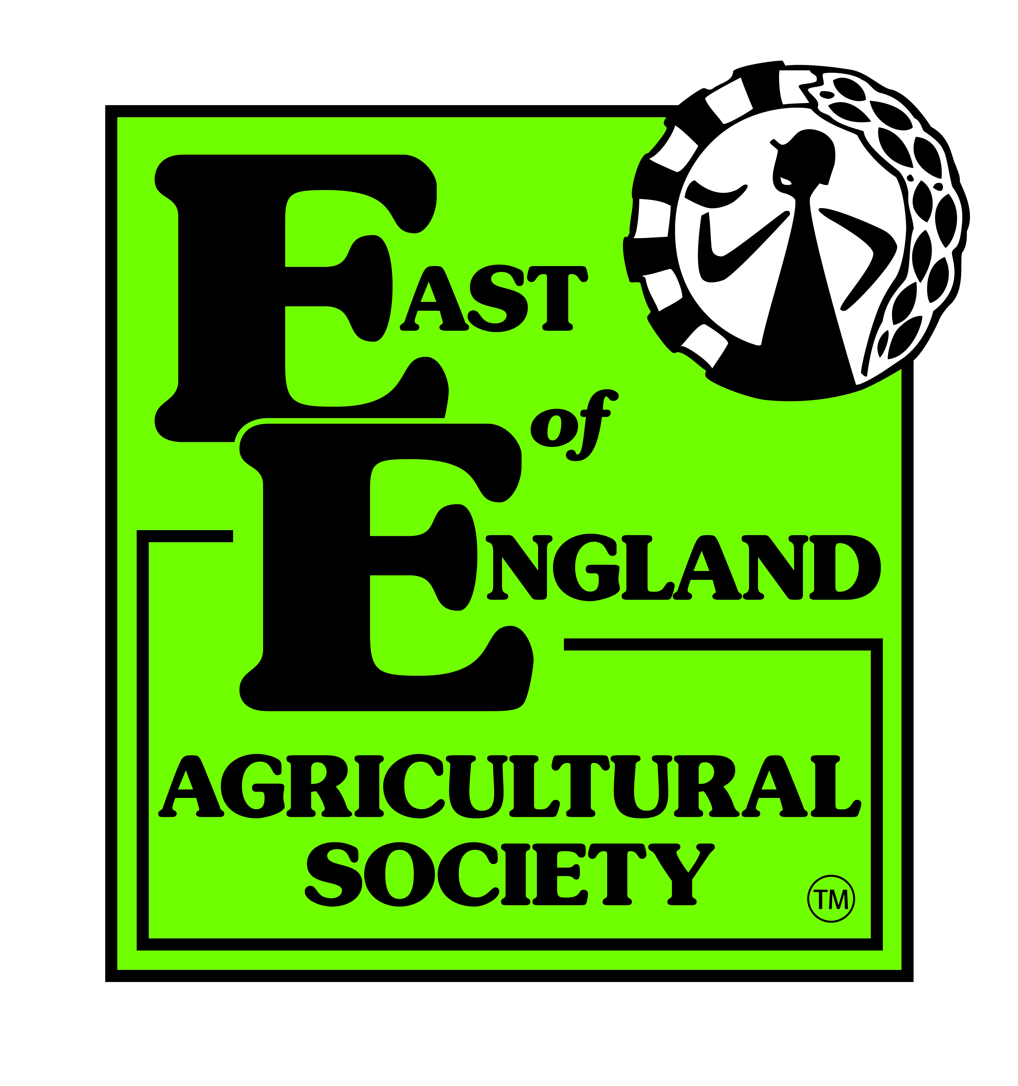
2019 East of England Agricultural Society
Membership Package

Individual, Joint or Life Members:
- Free Entry or free parking at the following;
  - Just Dogs Live
  - Festival of Hunting
  - Equifest
- Discounted tickets to the East of England Farming Conference
- Occasional opportunities for discounted tickets and offers for commercial events held on the showground.
- 2 x Society News Publications
  - Discount on advertising rates
- Monthly email newsletter
- Opportunity to publicise your event on the EEAS website
- Promote your event on the Members Market Place (launching April 19)
- Voting rights at the AGM
- Priority Invitation to Society events such as
  - Shuttleworth Lecture
  - Farm Walks
  - Peterborough Dinner

Corporate Members:
All of the above, minus the voting rights at the AGM
With the addition of;
- 8 Hours free use of the Northampton Suite
- 20% off room hire on the remaining showground suites
- Advertising opportunities in the Society News publication

2019 Prices
Type | Yearly Jan 2019 -Dec 2019 | Life
Individual (includes Cultiv8) | £30 | £550
Joint | £50 | £810
Student/Youth Member | £10 (Yearly Only)
Corporate | £350 (Yearly Only)

